

Software Engineering Department
Braude College of Engineering
Capstone Project – Phase A (61998)

Data Imbalance Testing and Handling System
CODE: 26-1-D-3
By:
Niv Oren
Daniel Levovsky

Advisor:
Dr. Avital Shulner Tal

Link to GitHub:
https://github.com/Niv0902/Niv-and-Dani---Data-Imbalance-Testing-and-Handling-System

1.Abstract
Many real-world classification datasets have far fewer examples of one class than others. In these cases, a model can look good on overall accuracy while still failing on the rare class that often matters most (for example: fraud, faults, or medical events). In practice, dealing with imbalance data is often done across different tools, with different metrics, and without clear documentation of what was changed, which makes it harder to compare and repeat.
In this project, we plan to build a data balancing system that will support the full process of working with imbalanced datasets in one place. The system will include various calculation methods for imbalance datasets and various balancing techniques. The goal is to help users understand the level of imbalance in their data, choose a way to handle it, and see how the data and results change after the handling step. We will also focus on producing clear explanations that describe what was done, so the work can be repeated and reviewed later on.

2. Introduction
In recent years, rapid progress in science and technology has led to the collection of massive amounts of data. However, this data is often not distributed evenly. This uneven distribution results in what is known as the class imbalance problem [Niaz et al. 2022] a phenomenon where the distribution of labels within a dataset is significantly skewed, resulting in biased and discriminated outputs. Because of this, models often become less accurate and reliable [Johnson & Khoshgoftaar, 2019], particularly in critical applications where accurate predictions for minority classes are top priority, such as fraud detection, medical diagnosis and security analysis [Hida & Nascimento, 2025]. For instance, as documented by [Kleinberg et al. 2022] in their study on dermatological diagnostic tools. Their research found that 97% of melanoma prediction models faced a high risk of bias due to severe data skew. In benchmark datasets, white faces accounted for 83.5% of samples, leaving non-White patients as a negligible minority. Consequently, these models became proficient at identifying cancer on lighter skin while frequently failing to recognize life-threatening conditions on darker skin tones.
Given the prevalence and high stakes of this issue, it is unsurprising that remediating class imbalance has become a primary focus in modern research, driving a surge in the development of specialized balancing methods and automated tools. There have been several methods developed to handle the imbalance problem, one of which is called sampling (re-sampling) [Nikpour et al., 2026]. Sampling techniques, also referred to as data preprocessing methods, involve manually re-adjusting the dataset's composition. This balance is achieved in two primary ways: by undersampling the majority class or oversampling the minority class, though it is also possible to combine both strategies for a hybrid approach. Oversampling involves increasing the frequency of specific data points by duplicating them or creating synthetic versions to give those points more weight, In contrast, Undersampling involves selecting only a subset of available data points and discarding the rest to reduce the overall volume of a specific group within a dataset [Longadge et al, 2013].
In this paper, we review several methodologies, commonly used for balancing datasets, and the software and tools that were built based on them. While those tools are sufficient at their designated purpose, most of them do not offer the user the freedom to choose and compare which method they wish to deploy in order to achieve a balanced dataset and they also don’t offer transparency as to how exactly the dataset changed and how the new imbalance ratio of the dataset stacks up to the old one. Hence, the goal of our project is to develop a system for the benefit of artificial intelligence researchers and developers that can run diagnostics on their dataset with full transparency as to what labels are over or under represents, assign an imbalance score before and after balancing and give them the freedom to choose exactly which method they wish to use.

3.Background and related work
Imbalanced data classification is a problem in which proportional class sizes of a dataset differ relatively by a substantial margin. In this, one class is at least depicted with just a fewer samples (e.g., the minority class) and the rest fall into the other class (e.g., the majority class)[KAUR et al., 2019].
There are several measurements for calculating the imbalance degree of a dataset [Nikpour et al., 2026]. For example, a metric called Imbalance Ratio (IR) [Orriols-Puig & Bernadó-Mansilla, 2009] that is calculated by dividing the number of samples in the majority class )N-maj( to the number of minority class samples )N-min( as:
IR = N-maj / N-min.
High values of IR indicate a severe skew that complicates the learning process for most machine learning models. As noted by Haixiang et al. [2017], while almost all real-world datasets exhibit some degree of imbalance, the classification of minority samples remains a uniquely challenging task. This difficulty arises because classical classifiers are internally designed to assume an even distribution of data.
Assessment metrics serve as the primary indicators for gauging a machine learning model's effectiveness. Although standard accuracy and error rates are frequently utilized, they often provide a skewed perspective when dealing with imbalanced datasets because they assume classes are distributed evenly. In binary classification, a more reliable way to evaluate performance is by utilizing a Confusion Matrix [Niaz et al. 2022].
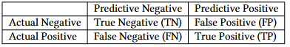
By utilizing these assessment metrics, [Shamsuddin & Ralescu, 2013, Niaz et al. ,2022] suggested another imbalance measurement called "The G-Mean"(geometric mean), is a metric used to show how well a classifier balances the accuracy between the positive and negative classes. By combining sensitivity (accuracy on the positive class) and specificity (accuracy on the negative class) into a single score, it measures overall balance. A low G-mean score indicates that the model is heavily biased toward one class, while a higher score shows that the model is performing well on both groups simultaneously. A complete list of additional assessment metrics is provided in Appendix A.
G-Mean =$\sqrt{\frac{TP}{TP+FN}*\frac{TN}{TN+FP}}$
Additionally, diagnosing a skewed dataset can be challenging due to a phenomenon called “The Accuracy Paradox” where high accuracy is not necessarily an indicator of high classifier performance [Valverde-Albacete & Peláez-Moreno, 2014]. In cases where classes are imbalanced, looking at overall accuracy can be very misleading. Imagine a dataset with 5,000 records where 99% belong to the majority group and only 1% belong to the minority. If a model fails to identify even a single minority case, it would still show a 99% accuracy rate. We can demonstrate it by applying the formula for accuracy computation as provided in Appendix A: (4,950 + 0) / (4,950 + 0 + 50 + 0). The core goal when working with imbalanced datasets is to successfully detect the minority samples. In the 99% accuracy example mentioned earlier, the model achieves a high score by simply ignoring the minority group altogether. [Rezvani & Wang, 2023].
Consequently, when Artificial Intelligence models are trained on datasets with a high Imbalance Ratio, they run a significant risk of misclassifying the minority cases which are the very samples that typically carry the highest importance or risk. This is not merely a mathematical oversight; it is a critical vulnerability that transforms statistical skew into real-world failure. When an algorithm is "blind" to the minority class, the resulting errors can manifest as systemic biases that disproportionately affect underrepresented groups or lead to catastrophic oversights in high-stakes environments. A landmark example of this phenomenon is documented by [Buolamwini & Gebru, 2018] who revealed that commercial facial recognition systems from major providers like IBM and Microsoft suffered from a profound "gender gap," with error rates reaching nearly 35% for darker-skinned women compared to less than 1% for lighter-skinned men. This disparity was a direct consequence of dataset imbalance, as the "state-of-the-art" training sets were heavily skewed toward lighter-skinned, male faces. Ultimately, because these groups were treated as a statistical minority in the training data, the models effectively dismissed their unique features as "noise," resulting in high failure rates for those individuals in real-world deployments.
Given the ethical risks and the deceptive nature of the accuracy paradox, remediating class imbalance has become a primary focus in machine learning research. The need for accurate minority representation has driven the development of specialized algorithms and automated software. The following sections review these state-of-the-art methodologies and evaluate existing tools currently available to practitioners.
3.1 Methodologies for Balancing
Broadly speaking, there are two primary ways to address class imbalance: the data-level approach and the algorithm-level approach. Data-level methods focus on changing the dataset itself to reach a closer to equal balance between groups. In contrast, the algorithm-level approach keeps the data as it is but tweaks the settings of the machine-learning model so it pays closer attention to the smaller class during the learning process. [Shamsuddin & Ralescu, 2013].
The data-level approach, often called an external technique, uses a pre-processing step to fix the balance of the dataset before the model ever sees it. This is usually done through under-sampling or over-sampling to lower the imbalance ratio. Under-sampling works by removing examples from the majority group to close the gap between classes, while over-sampling increases the size of the minority group by duplicating its examples or creating new ones. [Shamsuddin & Ralescu, 2013].
3.1.1 Over-sampling: Synthetic Minority Over-sampling Technique (SMOTE)
Synthetic Minority Over-sampling Technique (SMOTE) [Chawla et al., 2002] is a widely used method designed to balance datasets by generating new minority samples through interpolation. It works by identifying the k-nearest neighbors for each minority sample and then randomly selecting specific neighbors based on the amount of over-sampling needed. New, "synthetic" data points are then created along the lines connecting the original sample to these neighbors. While SMOTE is effective for many problems, it faces a few significant challenges. Because it generates these new samples without considering the overall structure of the data, it can lead to overgeneralization, where the model becomes too broad in its predictions. Additionally, since the algorithm doesn't account for the location of the majority class, it can accidentally create new samples that bleed into the majority class's territory, causing class overlapping. This makes it harder for the model to clearly distinguish where one group ends and the other begins.[Nikpour et al., 2026].
3.1.2 Under-sampling: NearMiss Approach
NearMiss is a collection of four under-sampling techniques that use specific rules to select which majority samples to keep [Mani & Zhang, 2003]. Instead of removing data randomly, these methods use the distance between points to balance the dataset:
NearMiss-1: Keeps majority samples that are closest, on average, to their three nearest minority neighbors.
NearMiss-2: Keeps majority samples that have the smallest average distance to their three farthest minority neighbors.
NearMiss-3: Keeps a specific number of majority samples that are closest to every individual minority sample, ensuring each minority point is "surrounded" by some majority data.
Most Distant: Keeps majority samples that are the furthest away from their three closest minority neighbors, focusing on the "safest" data points far from the class boundary [Nikpour et al., 2026].
Even though these methods use smart rules to pick which data to keep, they still face the same big problem as any strategy that deletes data. “The elimination of examples (down-sampling) from a class could lead to loss of potentially important information about the class” [Shamsuddin & Ralescu, 2013]. TODO: ASK HERE
In contrast to these data-centric modifications, the algorithm-level methods could be categorized as dedicated algorithms that directly learn the imbalance distribution from the classes in the datasets [Shamsuddin & Ralescu, 2013].
3.1.3 Algorithm-level approach: One-Class Learning
One-class learning algorithms, also referred to as recognition-based methods, operate by training the classifier to build a model based only on the characteristics and representation of the minority class. This approach learns strictly from minority examples rather than attempting to distinguish patterns between the majority and minority classes. However, the effectiveness of this method is highly dependent on the "effective boundary threshold," as a threshold that is too strict will exclude positive examples, while one that is too lenient will mistakenly include negative majority samples in the decision boundary. Furthermore, this approach remains less popular and "confined only to certain learning algorithms," as many standard classifiers such as Decision Trees, Naive Bayes, and k-Nearest Neighbors require data from both classes to function effectively. [Shamsuddin & Ralescu, 2013].
3.1.4 Algorithm-level approach: Cost-Sensitive Learning
Cost-sensitive learning is motivated by the fact that traditional algorithms often treat misclassification costs as equal, which does not reflect the "different natures of domain applications" where failing to detect a minority case is far more expensive than a false alarm. These approaches assign a larger penalty to false negatives than to false positives, thereby forcing the model to prioritize the minority class. Despite its theoretical benefits, "in most applications the real cost is not known," and the lack of a clear cost matrix makes this strategy difficult to implement accurately [Shamsuddin & Ralescu, 2013].
3.2 Existing Tools and Software
There are several existing tools that can balance imbalanced datasets. For example: Imbalanced-learn is the industry-standard Python library specifically designed to address class imbalance. It is an open-source project, part of the scikit-learn-contrib ecosystem, and is widely cited in academic research for its robust implementation of resampling algorithms.
The package smote-variants provides a python implementation of 85 over-sampling methods (Kovács, 2019b). This package provides multi-class compatible with 61 of the implemented binary over-sampling methods. It also includes a model selection framework that makes it easy to find the suitable over-sampling method for a specific dataset [Nikpour et al., 2026].
Another tool is WEKA (Waikato Environment for Knowledge Analysis). Weka is one of the most established open-source platforms for data mining and machine learning. Developed by the University of Waikato, it is a Java-based GUI tool that allows users to perform complex data balancing tasks without writing a single line of code. WEKA presents two solutions. First, to carry out a training data re-balancing. Second, perform a cost-sensitive classification. We selected the re-balancing procedure via instance filtering methods. Besides these, we can include the SMOTE preprocessing via the package manager [Rezvani & Wang, 2023].
The KEEL repository is a widely recognized digital library specifically designed to help researchers benchmark machine learning algorithms. It is particularly valuable for the study of imbalanced datasets, as it provides a standardized —such as oversampling or undersampling—on consistent, "real-world" problems to see which approach works best for detecting the minority class. In addition to providing a data repository, KEEL offers a comprehensive open-source software tool designed for various data mining tasks [Triguero et al., 2017]. The software features a specialized module for imbalanced learning, which includes several popular data-level algorithms that are easy to implement. To ensure scientific rigor, KEEL also provides a full suite of statistical procedures, including both parametric and non-parametric tests, allowing researchers to perform reliable pairwise comparisons between different algorithms [Nikpour et al., 2026].

4.Expected Achievements
This project aims to research, design, and implement a tool for labeled classification datasets that can measure how imbalanced the classes are and, when needed, apply a balancing method based on a balance score that we will define. The tool will be demonstrated on public datasets and will present clear “before” and “after” outputs, including class counts and simple visual summaries of the label distribution.
During development, we plan to include the most common families of data-level balancing methods: over-sampling, under-sampling, and a combined approach that uses both. This will let us compare different choices under the same workflow and show how each choice changes the dataset. We will also take into account known risks of these approaches. Over-sampling can increase the chance of overfitting by adding repeated or synthetic samples, while under-sampling can remove useful information and harm performance. Therefore, the tool outputs will clearly describe what changed and how the class distribution was affected.
We expect the final prototype to support a clear and fair way to compare results before and after balancing, because overall accuracy can be misleading in imbalanced datasets. The project will therefore focus on evaluation outputs that make minority-class performance visible, and it will document the main settings and choices used in each run so that results can be repeated and compared.

5.Research Process and System Implementation
The research process began with a comprehensive literature review about class imbalances in datasets used for machine learning. We focused on understanding exactly how class imbalance affects AI models. This phase established a theoretical foundation by understanding the Accuracy Paradox and the inherent risks of misclassification in high-stakes environments, as well as various measurements for calculating imbalance degree. Following this, we conducted an in-depth investigation into current balancing methodologies, specifically comparing Data-level (external) techniques like SMOTE and the NearMiss family against Algorithm-level (internal) methods like cost-sensitive and one-class learning. This analysis allowed us to identify the critical gap in existing software tools: while libraries like imbalanced-learn offer robust algorithmic depth, they lack the accessible, visual-first interface found in legacy tools like WEKA.
The implementation stage focuses on developing a system that integrates these advanced resampling heuristics into a user-friendly application. The process involves designing a pipeline where users can upload datasets in various formats, which the system then analyzes to calculate the Imbalance Ratio (IR) and visualize the data distribution. Based on this analysis, the tool suggests data-level balancing methods, specifically SMOTE for synthetic oversampling and NearMiss for informed Undersampling and generates a new, balanced version of the data. Finally, the process concludes with an evaluation phase, where the system’s effectiveness is validated by comparing the original and post-balancing IR scores, ensuring the tool provides a transparent and actionable solution for mitigating data-level bias.
5.1 System Architecture and requirements
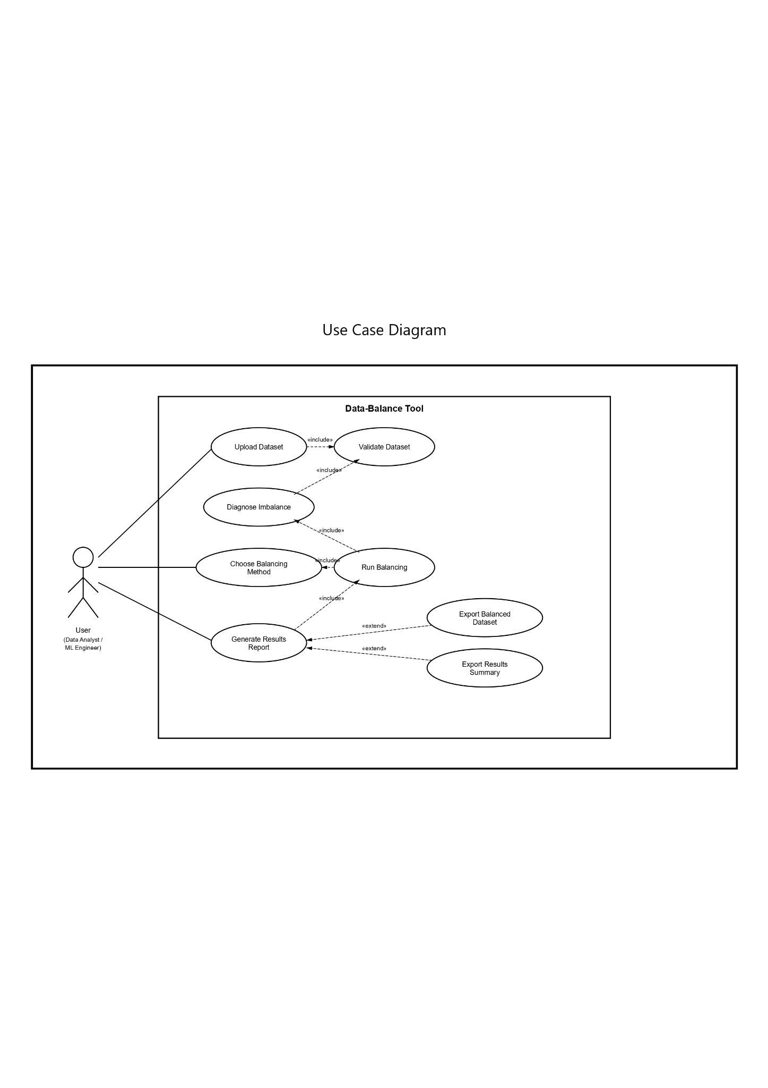
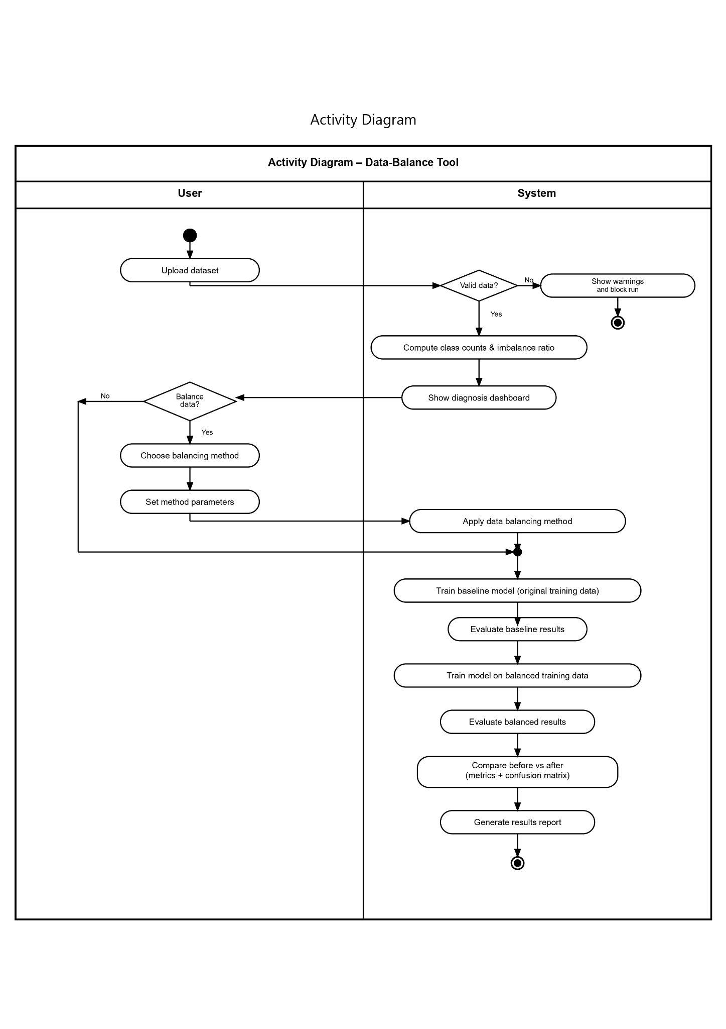

Functional requirements | Non-functional requirements
Upload a dataset and choose the label column. | Simple flow: upload, diagnose, balance, evaluate, export.
Check the data for basic problems and stop with a clear message if something is wrong. | Clear error messages for bad files, missing labels, or wrong formats.
Show class counts and how imbalanced the dataset is. | Handle noisy and overlapping data without crashing.
Balance the training data using built-in resampling methods. | Balancing is allowed only on the training data
Run the same model again after balancing and compare before vs after. | Same data and options should give roughly the same results every time .
Export the balanced dataset and a short results summary. | Speed: common datasets should run in a reasonable time
Show evaluation metrics that make sense for imbalance | Works on common browsers and screen sizes.
Show a simple before/after view
Save the run results so the user can compare different methods.

5.2. Tools and Technologies
5.2.1 Backend
The backend will be a Python service that is responsible for : validation, imbalance diagnosis, resampling, baseline training, and evaluation.
Main stack:
- Python 3
- FastAPI (REST API, request validation, automatic API docs)
- pandas, numpy (data loading and preprocessing)
- scikit-learn (baseline models, train/test split, metrics)
- imbalanced-learn (SMOTE, NearMiss, and related resampling methods)
Backend responsibilities
- File upload and parsing
- Input checks: label column exists, no empty labels, basic missing-value checks
- Imbalance diagnosis: class counts and imbalance ratio
- Safe split: train/test split before any balancing
- Resampling: apply only on training data
- Evaluation: run baseline vs balanced using the same split and same model
- Export: balanced dataset + results summary (tables)
5.2.2 Frontend
The frontend will be a web app that consumes the backend API and presents a simple guided flow with charts and results.
Main stack
- React + Next.js (UI and routing)
- TypeScript (type safety)
- Tailwind CSS (styling)
Frontend responsibilities
- Upload screen and label-column selection
- Diagnosis view: class distribution chart + imbalance ratio
- Balancing view: choose method and run
- Results view: before/after metrics
- Export controls (download balanced dataset and summary)

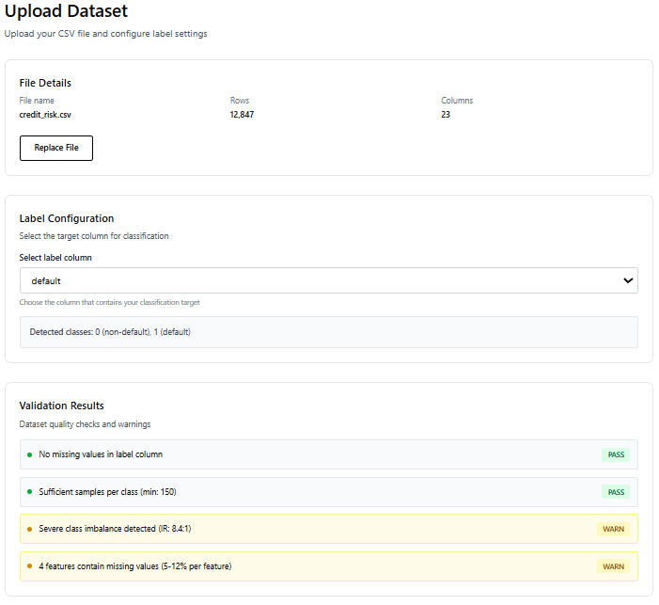
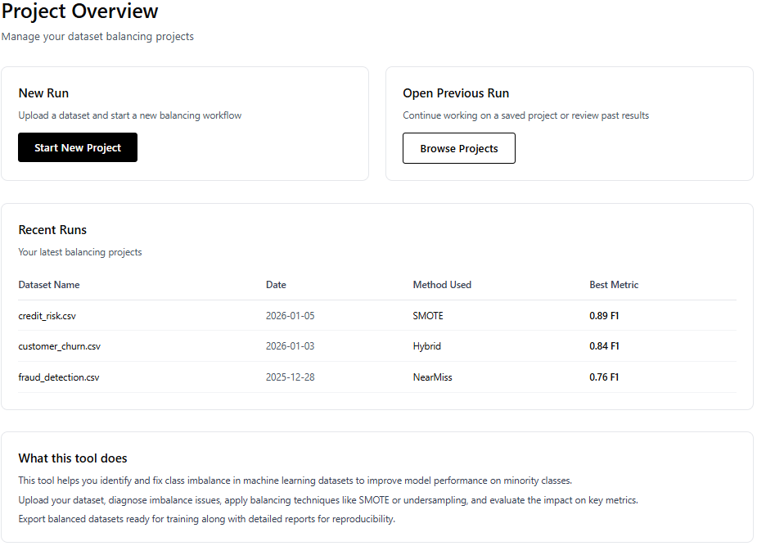
5.2.3 GUI
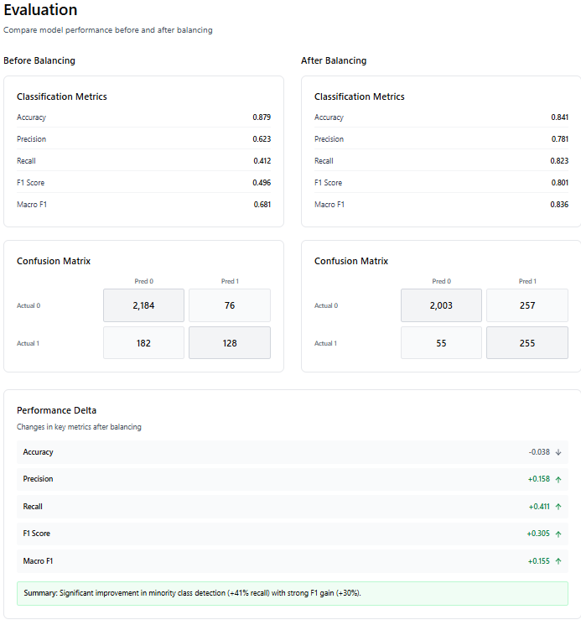
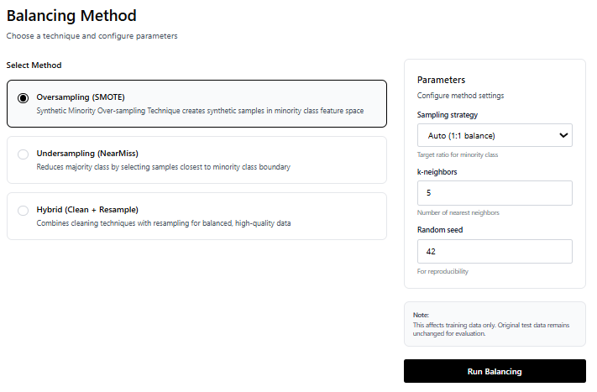
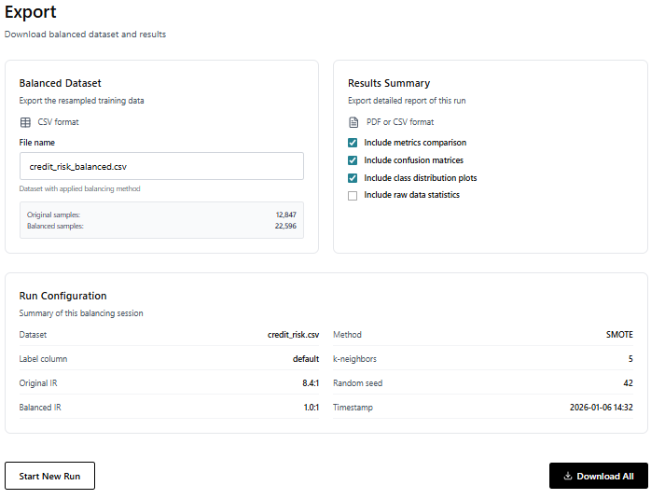
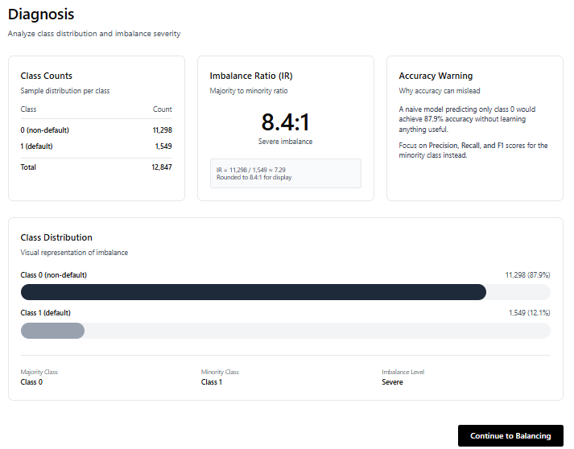

5.3 Expected challenges
We are expecting to face the following challenges while building the system :
- Balancing is not “free.” Over-sampling can increase class overlap or introduce synthetic samples that hurt generalization, while under-sampling can discard informative instances and reduce performance (Rezvani & Wang, 2023; Nikpour et al., 2026).
- Label noise and borderline cases. Noisy labels and ambiguous samples near decision boundaries can mislead both resampling methods and evaluation. To reduce this risk, the pipeline will include at least one technique designed to handle noise and overlap explicitly.
- Evaluation correctness and leakage. To avoid leakage, resampling must be applied only to the training split, while validation/test sets remain untouched (Kaur et al., 2020; Mortaz, 2020).
- Multi-class metrics are harder. In multi-class imbalance settings, metric choice is more complex and can distort conclusions, so the evaluation will include at least one metric tailored to multi-class imbalance assessment.
- Multi-class metrics are harder. In multi-class imbalance, choosing the wrong metric can hide failure modes. We will report at least one metric designed for multi-class imbalance, alongside standard per-class and macro metrics.
- Runtime and scalability. Some balancing methods become slow on larger datasets. We may need to limit supported dataset sizes, use simpler defaults, or optimize the pipeline to keep runs under the time target.
- Mixed data types and preprocessing issues. Real datasets often include categorical features, missing values, and messy columns. If preprocessing is inconsistent, balancing can break or produce unreliable results, so we must enforce clear validation and preprocessing rules.
- Parameter sensitivity and user misuse. Methods like SMOTE and NearMiss can behave very differently depending on parameter choices. If users pick bad settings, results may get worse, so we need safe defaults and clear warnings when a configuration is risky.

6. Evaluation
To make sure the system works correctly and the results can be trusted, we will use a structured testing plan. These tests check that each step of the pipeline produces the expected output and that the evaluation results are valid for research and reporting. We will test both correctness of the software pipeline and validity of the evaluation protocol. Software-level tests will verify that data parsing, label validation, resampling application, and exporting outputs work correctly and consistently. Research-level tests will verify that the experimental protocol avoids leakage (resampling only on training data) and that comparisons are fair (same splits, same models, same metrics) . We will include controlled runs on multiple datasets and report all configurations to support reproducibility and review .

6.1 Verification and Validation

Test ID | Description | Expected Result | Precondition
1 | Dataset upload | File is uploaded and the system shows file name, rows, and columns | Valid file
2 | Label selection | User selects a label column and the system confirms it is valid | Dataset uploaded
3 | Basic validation | System shows clear warnings for issues like missing values or empty labels | Dataset uploaded + label selected
4 | Imbalance diagnosis | System shows correct class counts | Label selected
5 | No leakage check | Balancing is applied only on training data, never on the test set | Balancing flow exists
6 | Run balancing | Balanced training data is created and IR before/after is shown | Method selected
7 | Before vs after evaluation | Results are compared using the same split, same model, same metrics | Baseline run + balanced run
8 | Measure runtime for a standard dataset. | Total runtime is under 60 seconds. | Standard dataset loaded.

6.2 Key Performance Indicators (KPIs)
- End-to-end runtime
Metric: Total time from clicking “Run” until results and exports are ready.
Target: Under 60 seconds for the supported dataset sizes.
- Imbalance reduction
Metric: Imbalance Ratio before vs after balancing.
Target: IR decreases after balancing.
- Minority-class recall improvement
Metric: Minority Recall before vs after balancing.
Target: Minority Recall increases on most datasets.
- Macro-F1 improvement
Metric: Macro-F1 before vs after balancing.
Target: Macro-F1 increases or stays stable, without major drops.
- Per-class reporting completeness
Metric: The report includes per-class Precision/Recall/F1 and macro averages for every run.
Target: 100% of runs include these values.
- Export success rate
Metric: Percentage of runs where dataset export and results summary export complete without errors.
Target: 100% in normal usage scenarios.

6.3 Success criteria for our project
• The proposed solution will correctly identify and describe the imbalance level in a given labeled classification dataset.
• The proposed solution will apply a balancing action when needed and will produce a new dataset with a clearer class distribution.
• The proposed solution will present a clear before-and-after comparison that shows the effect of the balancing step, especially on the rare class.

7.References

Alzoubi, S., Aldiabat, K., Al-diabat, M., & Abualigah, L. (2024). An extensive analysis of several methods for classifying unbalanced datasets. Journal of Autonomous Intelligence, 7(3), 1–9. https://pdfs.semanticscholar.org/1022/5068f4fce8cc164e94484b09347f3f6cfe7b.pdf
Ali, A., Shamsuddin, S. M., & Ralescu, A. L. (2013). Classification with class imbalance problem: A review. International Journal of Advances in Soft Computing and its Applications, 5(3)https://www.researchgate.net/profile/Aida-Ali-4/publication/288228469_Classification_with_class_imbalance_problem_A_review/links/57b556d008ae19a365faff16/Classification-with-class-imbalance-problem-A-review.pdf
Feng, Y., Zhou, M., & Tong, X. (2021). Imbalanced classification: A paradigm-based review. Statistical Analysis and Data Mining: The ASA Data Science Journal, 14(3).https://onlinelibrary.wiley.com/doi/abs/10.1002/sam.11538
Longadge, R., & Dongre, S. (2013). Class imbalance problem in data mining review. arXiv (arXiv:1305.1707). https://arxiv.org/pdf/1305.1707
Rezvani, M., & Wang, J. (2023). A comprehensive survey on class imbalance learning. Applied Soft Computing, 143, 110415. doi:10.1016/j.asoc.2023.110415. https://www.sciencedirect.com/science/article/pii/S1568494623004337
Mortaz, E. (2020). Imbalance accuracy metric for model selection in multi-class imbalance classification problems. Knowledge-Based Systems, 210, 106490. https://www.sciencedirect.com/science/article/pii/S0950705120306195.
Sidumo, B., Sonono, E., & Takaidza, I. (2022). An approach to multi-class imbalanced problem in ecology using machine learning. Ecological Informatics, 71, 101822. doi:10.1016/j.ecoinf.2022.101822. https://www.sciencedirect.com/science/article/pii/S1574954122002722
Dixit, D., Mani, G., Silakari, S., & Khamparia, A. (2023). A sampling technique for noisy and borderline examples to improve classification performance of imbalanced datasets. Applied Soft Computing, 142, 110361. doi:10.1016/j.asoc.2023.110361. https://www.sciencedirect.com/science/article/pii/S1568494623003794
Ren, J., Hao, H., Cheng, H., Yuan, B., & Li, H. (2023). A grouping-based oversampling method for imbalanced classification problems. Pattern Recognition, 133, 108992. doi:10.1016/j.patcog.2022.108992. https://www.sciencedirect.com/science/article/pii/S0031320322004721
Koziarski, M., & Wozniak, M. (2020). Combined cleaning and resampling algorithm for imbalanced data classification. Knowledge-Based Systems, 204, 106223. doi:10.1016/j.knosys.2020.106223. https://www.sciencedirect.com/science/article/pii/S0950705120304330
Taherkhani, A., Cosma, G., & McGinnity, T. M. (2020). AdaBoost-CNN: An adaptive boosting algorithm for convolutional neural networks for imbalanced datasets. Neurocomputing, 404, 351–366. doi:10.1016/j.neucom.2020.03.064. https://www.sciencedirect.com/science/article/pii/S0925231220304379
Nikpour, H., Brodie, A., & Girosi, F. (2026). Machine learning in imbalanced data: A survey and future directions. Expert Systems with Applications, 295, 128920. doi:10.1016/j.eswa.2025.128920. https://www.sciencedirect.com/science/article/pii/S0957417425025370
Hida, R., Guo, Q., Akiba, R., & Maruyama, Y. (2025). Overview of machine learning in class imbalance scenarios: A review. Expert Systems with Applications, 298, 129592. doi:10.1016/j.eswa.2025.129592. https://www.sciencedirect.com/science/article/pii/S0957417425032075
Amiri, M. A., Afshari, S., & Soltani, A. (2025). Machine learning approaches to traffic accident severity prediction: Addressing class imbalance. Machine Learning with Applications, 22, 100792
https://www.sciencedirect.com/science/article/pii/S2666827025001756
Ghosh, A., Bellinger, C., Corizzo, R., Branco, P., Krawczyk, B., Japkowicz, N., & Khoshgoftaar, T. M. (2023). The class imbalance problem in deep learning. Machine Learning, 112, 4807–4867. doi:10.1007/s10994-022-06268-8. https://link.springer.com/article/10.1007/s10994-022-06268-8
Kaur, H., Pannu, H. S., & Malhi, A. K. (2019). A systematic review on imbalanced data challenges in machine learning: Applications and solutions. ACM Computing Surveys, 52(4), Article 79, 36 pages. doi:10.1145/3343440. https://dl.acm.org/doi/epdf/10.1145/3343440
Niaz, N. U., Shahariar, K. M. N., & Patwary, M. J. A. (2022). Class imbalance problems in machine learning: A review of methods and future challenges. In Proceedings of the 2nd International Conference on Computing Advancements (ICCA ’22) (pp. 485–490). Association for Computing Machinery. doi:10.1145/3542954.3543024. https://dl.acm.org/doi/epdf/10.1145/3542954.3543024
Valverde-Albacete, F. J., & Peláez-Moreno, C. (2014). 100% classification accuracy considered harmful: The normalized information transfer factor explains the accuracy paradox. PLOS ONE, 9(1), e84217. http://journals.plos.org/plosone/article?id=10.1371/journal.pone.0084217

Valverde-Albacete, F. J., & Peláez-Moreno, C. (2014). 100% classification accuracy considered harmful: The normalized information transfer factor explains the accuracy paradox. PLOS ONE, 9(1), e84217. https://journals.plos.org/plosone/article?id=10.1371/journal.pone.0084217
Buolamwini, J., & Gebru, T. (2018). Gender shades: Intersectional accuracy disparities in commercial gender classification. Proceedings of Machine Learning Research, 81, 77–91. https://proceedings.mlr.press/v81/buolamwini18a/buolamwini18a.pdf
Kleinberg, G., Diaz, M. J., Batchu, S., & Lucke-Wold, B. (2022). Racial underrepresentation in dermatological datasets leads to biased machine learning models and inequitable healthcare. Journal of Biomedical Research & Management, 4(1).
(PDF) Racial underrepresentation in dermatological datasets leads to biased machine learning models and inequitable healthcare

Shorten, C., & Khoshgoftaar, T. M. (2019). A survey on image data augmentation for deep learning. Journal of Big Data, 6, 60. https://doi.org/10.1186/s40537-019-0197-0.

8.Appendices
Appendix A: Different Assessment Metrics
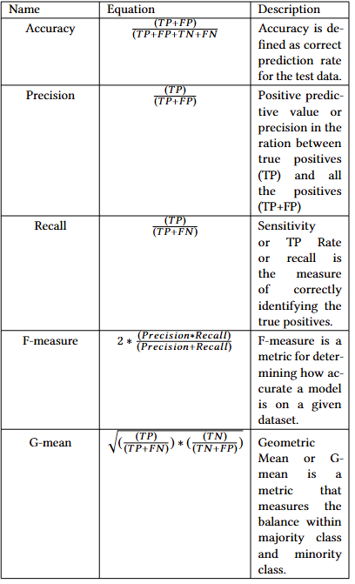
Reprinted from “Class Imbalance Problems in Machine Learning: A Review ofMethods And Future Challenges” by Nazim Uddin Niaz, K.M. Nadim Shahariar, Muhammed J. A. Patwary, 2022.

